Exercise 16_Pointers

s214417 Lukas Schou

s214413 Christian Cederhorn

**1. Use a pointer to change the value of an integer variable. You can declare a pointer to an integer variable like this:**



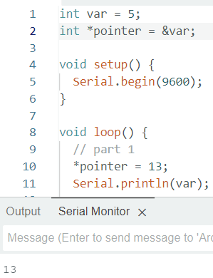

**2. Examine the following code. What is it doing?**

The code above prints the address of a pointer which is set and the value of the pointer, which is the values in the array a.

The code above returns:

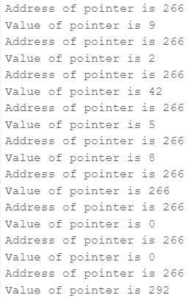

**3. Write a function that swaps the value of two integer variables using pointers**

The variables are swapped with pointers with the help of a temporary variable.

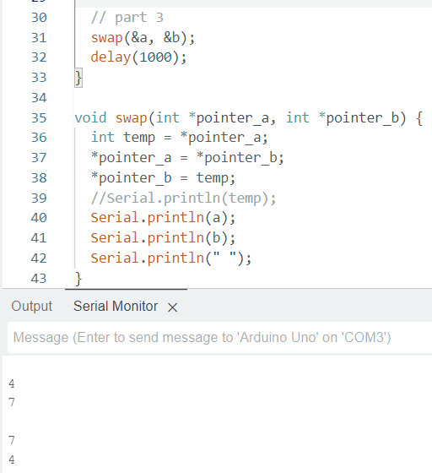

Questions

* 16a: What would you find if you read the memory where a pointer is stored?

If you read the memory where a pointer is stored, you would find the memory address it points to.

* 16b: Why does the value of the pointer in 16.2 change to something seemingly random after the first five iterations?

When the pointer values go above five, seemingly random values are shown, since the program doesn’t have any further information. Therefore, it is important to ensure the pointer stays withing the boundaries or it could lead to misinformation.